

**CIS 11042 – Practical for Essential of ICT and PC Applications**

**Information And Communication Technology**

**Faculty of Technology**

**South Eastern University Of Sri Lanka**

***Reg. Number:*** *SEU/IS/22/ICT/075*

***Academic Year:*** *22/23*

***Date:*** *25.05.2025*

***Practical Number:*** *Lab Sheet 21*

***Title:*** *working with Communication software.*

**z**

**Task:**

**1.**

**a.**

**i.** Open your “web browser” 🡪 Go to “LinkedIn website” 🡪 Enter your “login  
 credentials” (Mail Id or phone number) 🡪 Enter your “password” 🡪 Click on  
 "Sign in" 🡪 then you can access your LinkedIn account.

**ii.**  Navigate to Your “Profile” 🡪 click on “Settings & Privacy”

**iii. Connecting with People in Your Network**

* Create a “Strong Profile” 🡪 Build Your Network 🡪 Engage in Content  
   🡪 Direct Messaging.

**Applying for Jobs**

* Job Search 🡪 Apply Through LinkedIn 🡪 Connect with Recruiters   
  🡪 Use Your Network.

**Providing Job Opportunities**

* Share Job Openings 🡪 Use the Job Posting Feature 🡪  
  Recommendations 🡪 Participate in Groups.

**iv.** Log In to “LinkedIn” 🡪 Access the Messaging Feature 🡪 Select a Connection  
 🡪Compose Your Message 🡪 Send the Message.  
  
 **v. Creating and Publishing Posts**

* Log In 🡪 Navigate to the Home Feed 🡪 Create a Post 🡪 Compose   
  Your Post 🡪 Add Media 🡪 Tag People or Companies 🡪 Add Hashtags  
  🡪 Choose Post Visibility 🡪 Publish.

**Engaging with Activities**

* Respond to Comments 🡪 Like and Share 🡪 Direct Messages.

**vi.** Log in to “LinkedIn” 🡪 Go to the “Homepage” 🡪 View “Posts”.

**vii.**

* Create a Company Page 🡪 Optimize Your Company Page.
* Content Sharing.
* LinkedIn Ads.
* LinkedIn Showcase Pages.
* LinkedIn Groups.
* LinkedIn Events.
* LinkedIn Analytics.
* Employee Advocacy.
* LinkedIn Learning.
* Recruitment and Talent Solutions.
* Customer Engagement.

**viii.** Click on “me” drop down arrow 🡪 Click on “sign out”.

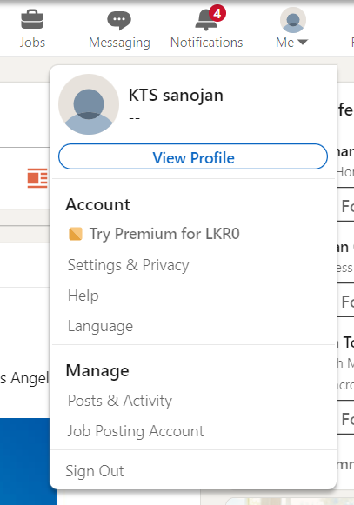

**b.   
 i.** Open “Twitter Website” 🡪 Enter “Username or Email” 🡪 Enter “Password”  
 🡪 Click "Log in" 🡪 Access Your Twitter Account.

**ii.** left site you can see so many tabs 🡪 in there click on “profile” 🡪  
 here you can customize your profile setting.

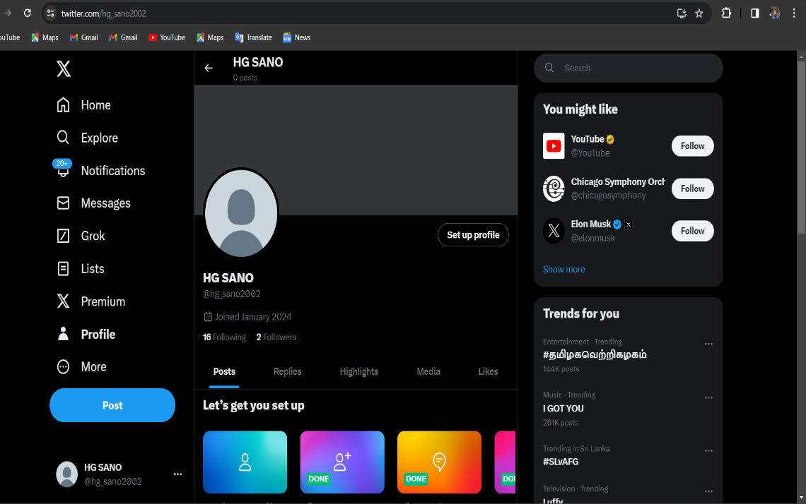

**iii.** right site top corner you can see search box 🡪 in here you can search people.  
  
 **iv.** Navigate to the “Tweet Composer” 🡪 Compose Your Tweet 🡪 Add Media  
 (Optional) 🡪 Tag Users (Optional) 🡪 Add Hashtags (Optional) 🡪 Review Your  
 Tweet 🡪 Tweet.

**v. See Tweets :-** Scroll through the timeline to see tweets from people you follow.

**Like a Tweet :-** Below each tweet, you can see a heart icon 🡪 click on the heart   
 icon to like the tweet.

 **Retweet a Tweet :-** Below each tweet, you can see a circular arrow icon 🡪 click   
 on it to retweet the tweet.

**Comment on a Tweet :-** Below each tweet, you can see like this icon 🡪  
 click on it 🡪 type your comment & sent.

 **Send Direct Messages :-** go in site of the tweeter id 🡪 you can see like this   
 icon 🡪 click on it & sent message.

**Sign out :-** below the home page in left site corner you can see there dots 🡪  
 click on it 🡪 then you’ll see log out option 🡪 click on it.

**C.   
 i.** Open WhatsApp 🡪 go to a contact 🡪 type message 🡪 sent it.

**ii.** Open WhatsApp 🡪 click on “+” symbol in the top right corner 🡪 click on   
 “new group” 🡪 select contacts & click “next” 🡪 type group name & click  
 create 🡪 In the created group you can type the message & send.

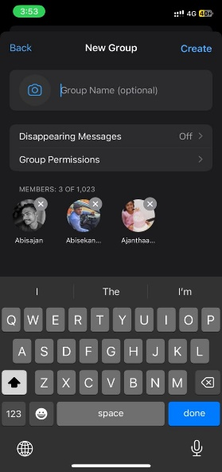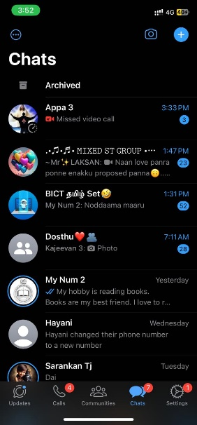

**iii.** Open WhatsApp 🡪 click on “+” symbol in the top right corner 🡪 click on   
 “new broadcast” 🡪 select contacts & click “create” 🡪 In the created   
 broadcast you can type message & send.

**iv.** Open any bowser in your pc 🡪 search WhatsApp web 🡪 open WhatsApp web  
 (you can see a QR Code) 🡪 in your phone go to WhatsApp settings 🡪 Click on  
 “Linked Devices” 🡪 click on “link a device” 🡪 scan the QR code that is in your  
 PC.

**V.** Go to status tab 🡪 here you can see all statuses 🡪 click on status 🡪  
 in here you can upload a status.   
  
 **vi.** Open any contact number 🡪 click on call icon 🡪 here you can make video   
 or audio call.  
  
 **vii.**   
 **1.** Open “WhatsApp” 🡪 go to “settings” 🡪 click on “Account”  
 🡪 in here you can customize account setting.   
  
 **2.** Open “WhatsApp” 🡪 go to “settings” 🡪 click on “chat”  
 🡪 in here you can customize chat setting.

**3.** Open “WhatsApp” 🡪 go to “settings” 🡪 click on “Notification”  
 🡪 in here you can customize Notification setting.  
  
 **4.** Click on the “+” icon that is in the top right corner 🡪 click on "New   
 Contact” 🡪 if the number person hasn’t WhatsApp there will be show  
 "Invite to WhatsApp" 🡪 then you’ll send the invite link to that number  
 by using another app.

**d.**

**a.** Open “browser” 🡪 search “Facebook login” 🡪 Type “phone number or e-mail”  
 & type password 🡪 click on “login”.

**b.** go to “home page” 🡪 here you can see posts 🡪 the bottom of the post   
 you can see three icon 🡪 1st like icon , 2nd comment icon , 3rd share icon   
 🡪 in here you can like, comment & share the post.

**c.   
 Make a post :-** in the home page click on “photo/video” 🡪 in here   
 you can make a post.

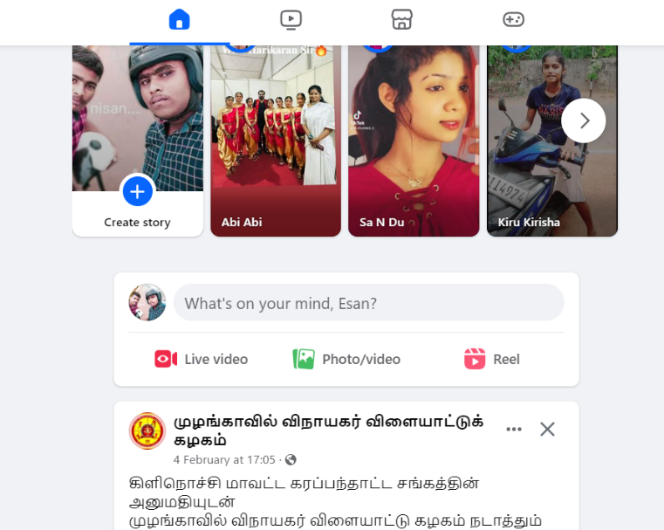

**Sharing live video :-** in the home page click on “live video” 🡪 in here  
 you can share live video.

**d.** go to your profile 🡪 click on edit icon 🡪 in here you can customize profile setting.

**e.**

Click here first

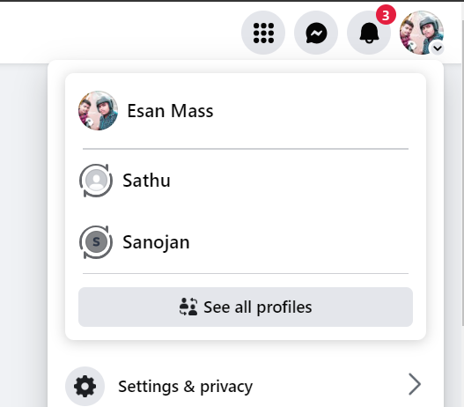

Click here 2nd

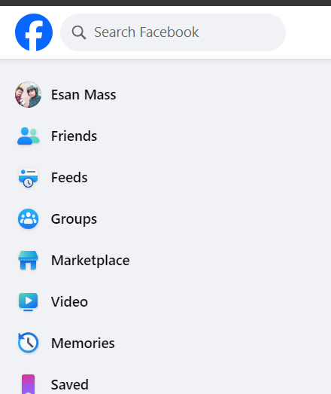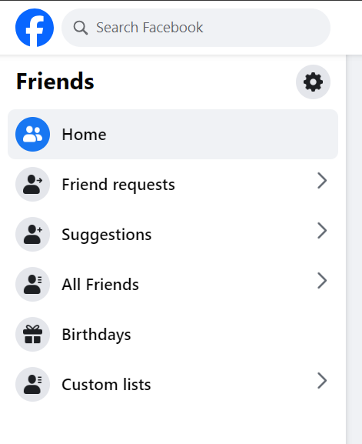 **f.** click on “friends” 🡪 go to friend request 🡪 in here you can sent & accept   
 friend request

**g.** in the search box search their Facebook id & go to their account 🡪  
 in there click on “message” 🡪 in here you can sent message directly.

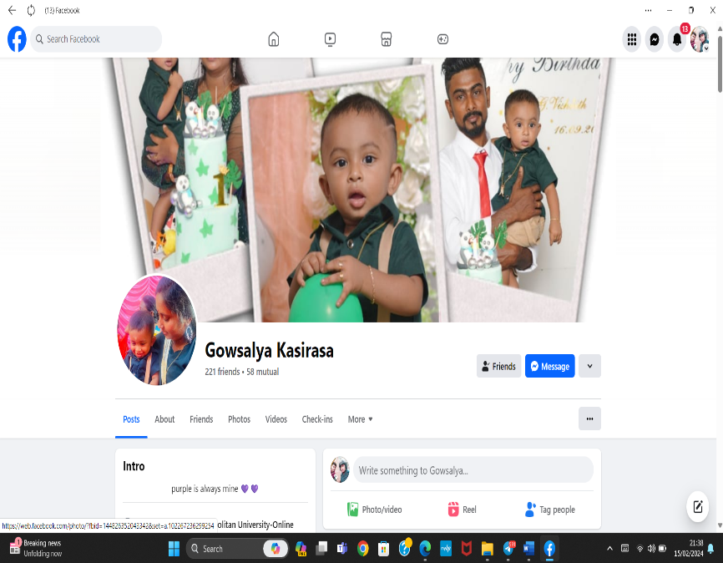

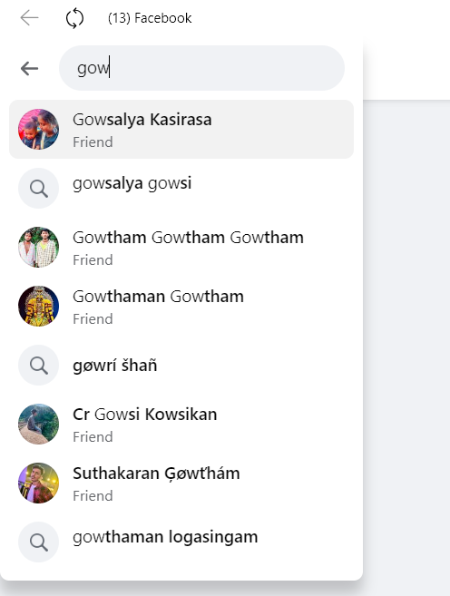

**h.** left site of the home page you can see so many tabs 🡪 in here Select either  
 "Group", "Event," or "Page" 🡪 Set up details by following the instructions 🡪  
 Modify the parameters 🡪 Increase the content 🡪 Write or publish.

**i.** click “What's on your mind?” 🡪 Scroll down and click Ask for Recommendations  
 click on “Add a Location” to select the city where you're looking for  
 recommendations.



**j.** • To increase the security of your Facebook account, go to Settings & Privacy   
 🡪 Settings 🡪 Security and sign in.

• Set up login alerts, examine active sessions, enable two-factor authentication,   
 and change your password on a regular basis.

• To aid with account recovery, confirm that the contact information you provided   
 is correct.

**k.** go to “setting & privacy” 🡪 click on “privacy centre” 🡪 in here you can customize   
 setting privacy.

**j.** click on your account drop down arrow 🡪 click on “Log out”.

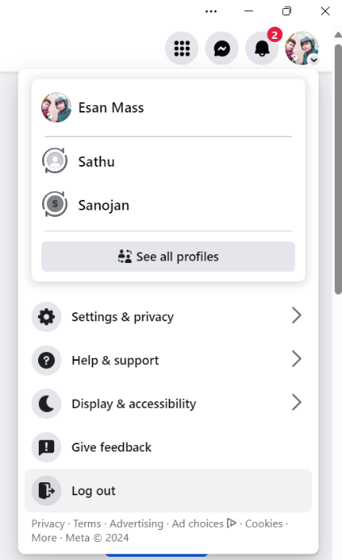

**e.**

**a.**

**i.**

1. go to Gmail sign-up screen 🡪 select "Create account" 🡪 Enter your details  
 (password, desired email address, and name) 🡪 Include a phone number in   
 order to verify 🡪 Finish the security inspection 🡪 After accepting the terms,  
 click "Next" 🡪 Modify the settings on your account 🡪 Your Gmail account  
 is prepared.

2. go to your Gmail account 🡪 click on "Compose" 🡪 Enter message, subject,   
 and email address of recipient , Click the paperclip symbol to attach a file  
 or picture , Click the link button to input a link , In order to send the  
 email 🡪 click "Send".

3. Launch Gmail 🡪 Click the checkboxes to choose emails 🡪 Press "Delete" on  
 your keyboard or click the "Delete" button 🡪 You can also select "Move to  
 Trash" 🡪 Select "Empty Trash now" under "Trash" to permanently erase.

**ii.** 1. Launch Google Drive 🡪 Click "New" on the left 🡪 Choose "Folder." 🡪  
 Give your folder a name 🡪 Select "Create".  
  
 2. Launch Google Drive 🡪 Select "New" from the left-hand menu 🡪   
 click on “file upload” in here you can upload your file.  
  
 3. Launch Google Drive 🡪 Select "New" from the left-hand menu 🡪   
 click on “folder upload” in here you can upload your folder.

**iii.** 1. Launch Google Docs 🡪 click on “new blank document”.

2. launch google docs 🡪 go to “template gallery” 🡪 click a “template” &  
 do your work.

3. Open a document  
 • To add text :- click where you want to start typing.   
 • For objects :- click "Insert" 🡪 choose element.   
 • Format text using toolbar options.   
 • To move objects :- click and drag.

4. Start the Google Docs file 🡪 To add comments, either highlight the text or  
 find the relevant area 🡪 Select the "Comment" button 🡪 Type your  
 feedback 🡪 Hit the Enter key. Now that comments are accessible, they can  
 be addressed or resolved.

5. Launch Google Documents 🡪 Start the file 🡪 Select "Share" from the drop-  
 down menu 🡪 Type in email addresses 🡪 Select the watching, commenting,  
 and editing rights 🡪 If desired, include a message 🡪 Select "Send." 🡪   
 Depending on the permissions allowed, recipients of an email can modify,  
 comment, or see the content.

6. Open your Google Docs document 🡪 Click "Share" in the top right 🡪 In the  
 sharing settings, click "Copy link" 🡪 Choose the sharing settings (view,  
 comment, or edit) 🡪 Click "Copy" 🡪 Share the copied link with others via  
 email or messaging.

7. Find the file that you wish to download 🡪 Select "File" from the menu 🡪  
 select and hold "Download" Select a format (such as Microsoft Word) 🡪  
 Your device will begin to download the document.

**iv.** 1. Open Google Sheet 🡪 in the home screen select "Blank spreadsheet".

2. launch Google Sheet 🡪 select "Template Gallery" 🡪 Select a template.

3. open Google Sheet 🡪 Select "Share" from the upper right menu 🡪 Type in  
 email addresses 🡪 Select the desired access level, "Viewer" for view-only,  
 "Editor" for edits, or "Commenter" for comments.

4. open Google Sheet 🡪 Select "Share" from the drop-down menu 🡪 Select  
 "Copy link" from the bottom-left option 🡪 Select who has access , "Anyone  
 with the link" or certain individuals 🡪 Assign authorization.

5. Select "File" from the menu 🡪 Select "Download" 🡪 Decide on the format  
 you want (Excel, for example) 🡪 The download will initiate on its own.

**v.** 1. Open Google Slides 🡪 Click on “blank presentation”.

2. Launch Google Slides 🡪 choose a template from the collection of templates   
 🡪 Modify the template.

3. Launch Google Slides 🡪 Select "Share" from the top-right menu 🡪 Include  
 email addresses 🡪 Select between watching, commenting, and editing access  
 🡪 Feel free to include a note 🡪 Select "Send" 🡪 Depending on the  
 permissions you gave, the recipients can now watch, change, and leave  
 comments on your presentation.

4. Start your presentation in Google Slides 🡪 Select "Share" from the drop-down  
 menu 🡪 Choose "Copy link" from the sharing menu 🡪 Modify authorizations  
 as necessary 🡪 Send a message or email with the copied link 🡪 With the   
 shared link, other people can now view your presentation.

5. Select "File" from the menu 🡪 Select "Download" 🡪 Decide on the format you  
 want 🡪 The download will initiate on its own.

**vi.** 1. Open Google Classroom 🡪 click on "+" button 🡪 select "Create class" 🡪 Enter  
 the section and name of the class 🡪 Select "Create".

2. Launch Google Classroom 🡪 Select the class by clicking 🡪 In the upper right  
 corner, select "People" 🡪 select "Invite students" 🡪 Select a choice (class code,   
 email, etc.) 🡪 Disseminate the invitation details 🡪 Students accept the email  
 invitation or enter the code to join.

3. Launch Google Classroom 🡪 click on "+" symbol or "Join class." 🡪 Type in the   
 teacher-provided class code 🡪 Select "Join".

4. Launch Google Classroom 🡪 Find your way to your class 🡪 Select the tab for  
 classwork 🡪 Click "Create" 🡪 click "Material" 🡪 Provide instructional materials   
 via links or uploads 🡪 If required, include a title, instructions, and a deadline 🡪  
 Click "Save" or "Assign" to distribute the resources to your pupils.

5. Launch Google Classroom 🡪 Decide on the course 🡪 Click "Classwork" 🡪  
 click "Create" 🡪 select "Question" to start a new question 🡪 Use the same  
 procedures for assignments or announcements, but choose "Assignment" or  
 "Announcement" Upon completing the form and attaching any necessary files,  
 select "Assign" or "Post".

**vii.** 1. Start a Google Form 🡪 Press "Blank form" to start a new form 🡪 Include   
 questions and a title 🡪 Adjust the parameters and question types 🡪 To  
 examine the results, click "Responses" or "Send" to share.

2. open Google Form 🡪 Select a template 🡪 Add questions to make your form  
 more unique 🡪 Modify the parameters as necessary 🡪 To share, click  
 "Preview" or "Send".

3. Start a Google Form 🡪 Press the "Customize Theme" button 🡪 Select a ready-  
 made theme or select "Custom" to change the fonts and colors 🡪 Modify the  
 colors of the form, header, and background 🡪 Select "Done".

4. open Google Form 🡪 Choose the form you wish to see a preview of 🡪 Select  
 Preview by clicking the "eye" icon.

5. open Google Form 🡪 Open an already-existing form or create a new one 🡪  
 Select "Send" from the menu in the upper-right corner 🡪 Select the method of  
 delivery (email, link, or embed) 🡪 Adjust the parameters 🡪 Select "Send" 🡪  
 Distribute the form appropriately.

**viii.** 1. Open the Google Hangout app 🡪 To call a specific person, click on their name  
 🡪 Click the video icon in the chat box 🡪 Hold off till the person responds 🡪  
 Enjoy your video call after you've connected.

2. Open Hangouts app 🡪 click "Chat" or "Contacts" 🡪 Select contact or enter  
 number 🡪 click on phone icon 🡪 Choose "Voice call" or "Video call" 🡪 Wait